Subnetwork:-
1)sub network or subnet is a logical subdivision of an IP network. The practice of dividing a network into two or more networks is called sub netting.
OR

2) A subnet is used to divide a large network into a number of smaller, linked networks, which helps to minimize traffic.

Sub netting offers many advantages. Some of them are.
1. It provides security to the network.
2. Speeds up the network thus improving the performance of the network.
3. It allows for better organization of the resources.

Week10:- Implementation of Subnetting using packet tracer.

Subnetting in packet tracer:-
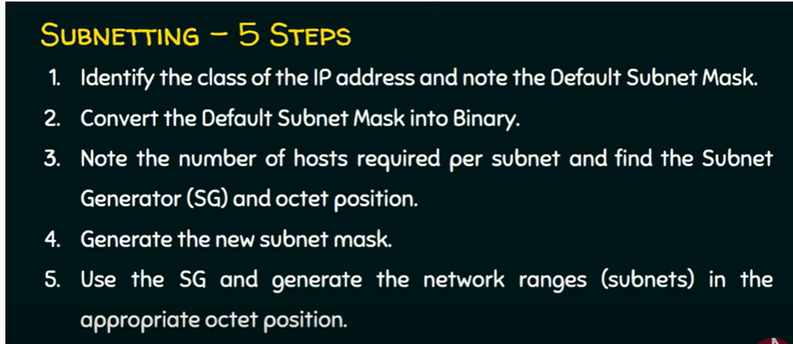

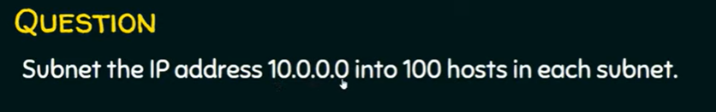

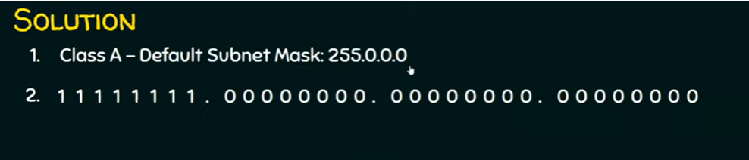

Mask for classful addressing are:-
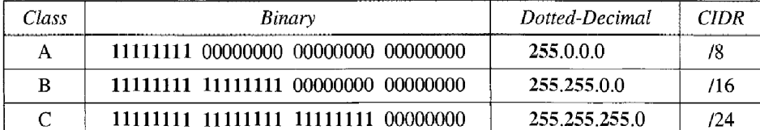

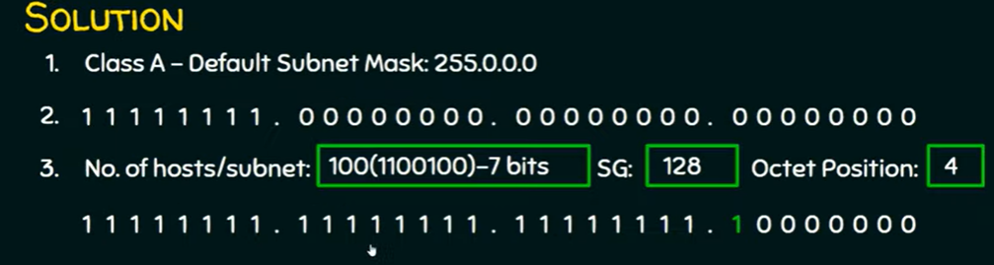

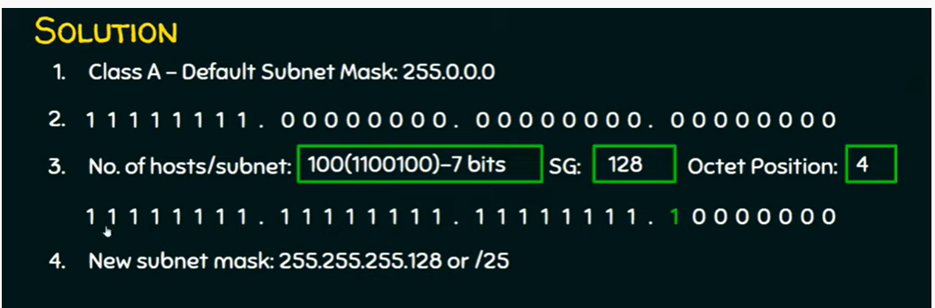

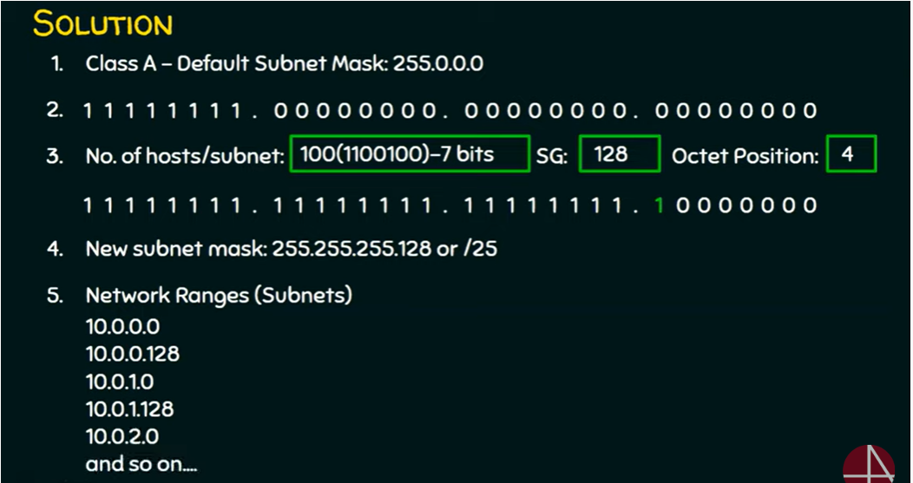

Add 128 in last position we get 10.0.0.128 and again add 128at last we get 128+128=256 10.0.0.256 is wrong IP address range class address is 0-255 so now change 2 position to 1 we get IP address as
10.0.1.0 and then add 128 then we get 10.0.1.128 . again add 128 which is 256 can’t add so 10.0.2.0 and so on……………….

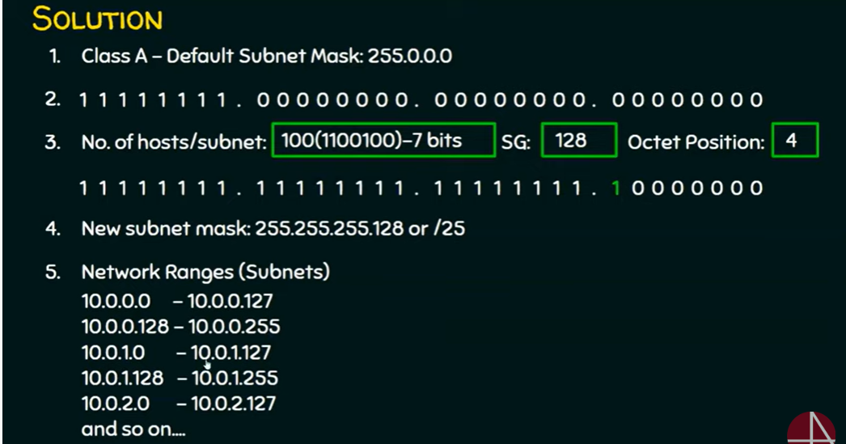

In each subnet there are 128 IP addresses
126 IP address are usable and 126 IP addreess are assigned to 126 hosts in a subnet .
1st address represent network address
Last address represent broadcast address
Broadcast address:-
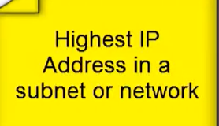

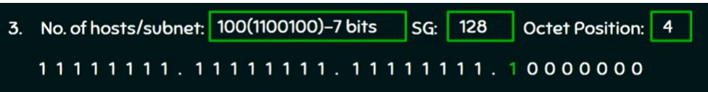

Number of hosts per network are: 2 power of number of zeros in a subnet in the above number of zeros are seven. So number of hosts per network are 2^7

Number of subnets are : 2 power of number of 1’s . in the above subnet number in 2nd,3rd,4th octet zeros are replaced with 1’s so total number of 1’s are 17 so 2^17 subnets are possible

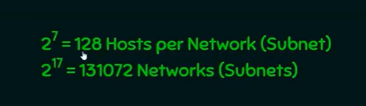

Implementation of subnet in packet tracer

